**Terpbuy SQL Assignment Questions and Answers**

**SQL Query Execution with Screenshots for Reference:**

Q1. How many rows of data are stored for each table in the database? List the name of each table followed by the number of rows it has.

Ans 1.

SELECT 'category' AS Table_Name, COUNT(*) AS Count_Of_Rows

FROM category

UNION

SELECT 'customer', COUNT(*)

FROM customer

UNION

SELECT 'department', COUNT(*)

FROM department

UNION

SELECT 'order_line', COUNT(*)

FROM order_line

UNION

SELECT 'orders', COUNT(*)

FROM orders

UNION

SELECT 'product', COUNT(*)

FROM product;

6 rows were returned in the answer.

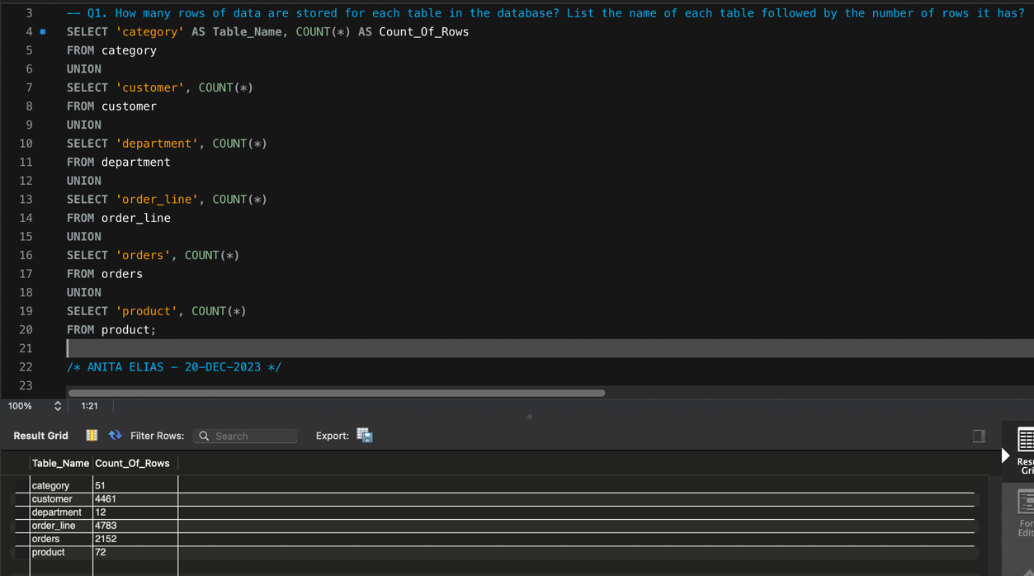

Q2. Which products are considered high-priced products? A high-priced product has a price exceeding $100.00. List the names and prices of the high-priced products.

Ans 2.

SELECT product_name AS Product_Name, product_price AS Product_Price

FROM product

WHERE product_price > 100;

16 rows were returned in the answer.

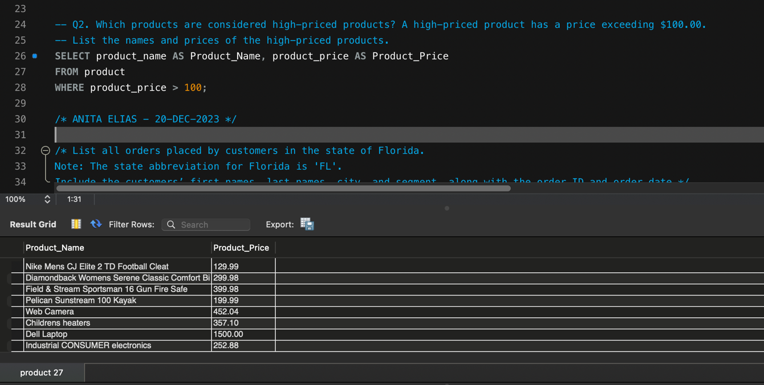

Q3. List all orders placed by customers in the state of Florida. Note: The state abbreviation for Florida is 'FL'. Include the customers’ first names, last names, city, and segment, along with the order ID and order date.

Ans 3.

SELECT c.first_name AS Customer_First_Name, c.last_name AS Customer_Last_Name, c.city AS City, c.segment AS Segment,

o.order_ID AS Order_ID, o.order_date AS Order_Date

FROM customer c

INNER JOIN orders o ON o.customer_id = c.customer_id

WHERE c.state = 'FL';

69 rows were returned in the answer.

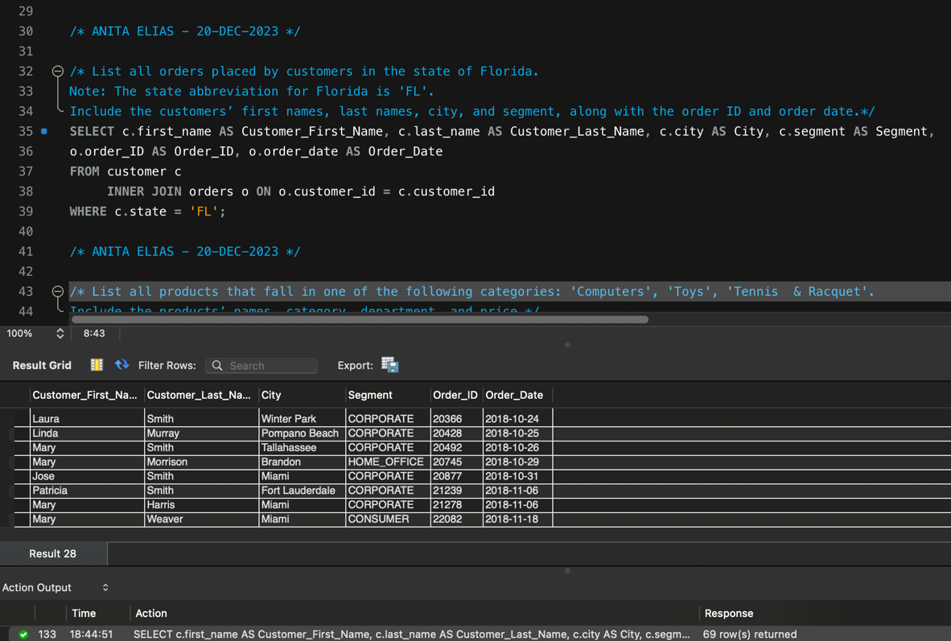

Q4. List all products that fall in one of the following categories: 'Computers', 'Toys', 'Tennis & Racquet'. Include the products’ names, category, department, and price.

Ans 4.

SELECT p.product_name AS Product_Name, ca.category_name AS Category, de.department_name as Department_Name, p.product_price AS Product_Price

FROM product p

INNER JOIN category ca ON ca.category_id = p.category_id

INNER JOIN department de ON de.department_id = p.department_id

WHERE ca.category_name IN ('Computers', 'Toys', 'Tennis & Racquet');

2 rows were returned in the answer.

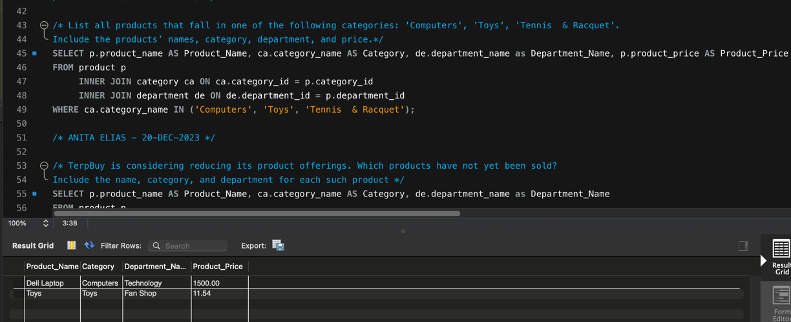

Q5. TerpBuy is considering reducing its product offerings. Which products have not yet been sold? Include the name, category, and department for each such product.

Ans 5.

SELECT p.product_name AS Product_Name, ca.category_name AS Category, de.department_name as Department_Name

FROM product p

INNER JOIN category ca ON ca.category_id = p.category_id

INNER JOIN department de ON de.department_id = p.department_id

INNER JOIN order_line ol ON ol.product_id = p.product_id

WHERE ol.quantity_sold = 0;

0 rows were returned in the answer.

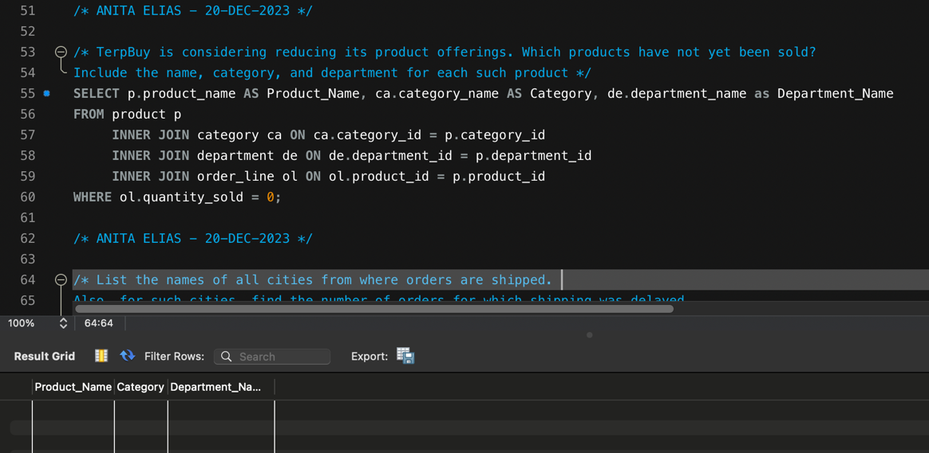

Q6. List the names of all cities from where orders are shipped. Also, for such cities, find the number of orders for which shipping was delayed. Sort the list of cities in order from the highest to the least number of shipping orders.

Ans 6.

SELECT o.order_city AS City_Name, COUNT(o.order_id) AS No_of_orders_shipping_delayed

FROM orders o

WHERE o.actual_shipping_days > o.scheduled_shipping_days

GROUP BY o.order_city

ORDER BY COUNT(o.order_id) DESC;

140 rows were returned in the answer.

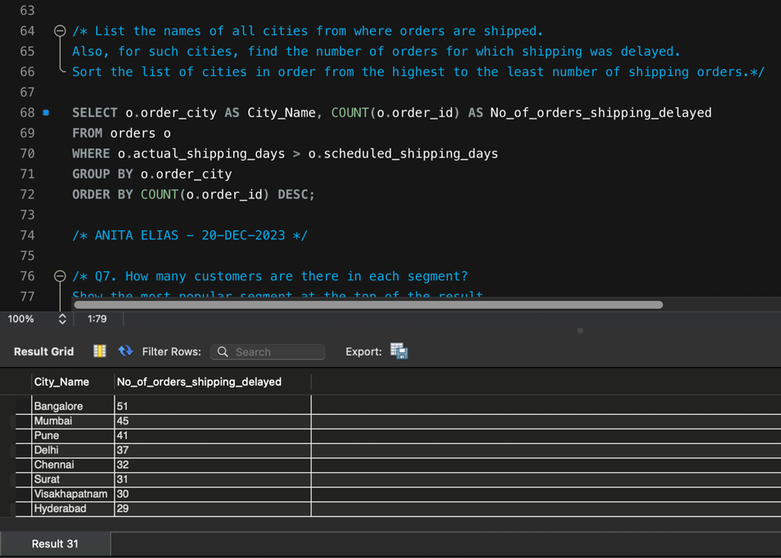

Q7. How many customers are there in each segment? Show the most popular segment at the top of the result. Incorporate a column alias in the result.

Ans 7.

SELECT c.segment AS Customer_Segment_Ratedby_Popularity, COUNT(c.customer_id) AS No_of_Customers_in_the_Segment

FROM customer c

GROUP BY Customer_Segment_Ratedby_Popularity

ORDER BY COUNT(c.customer_id) DESC;

3 rows were returned in the answer.

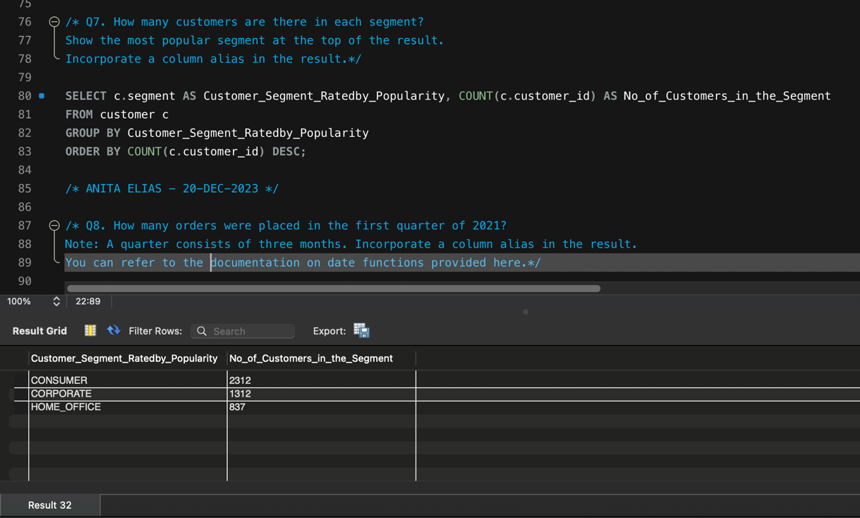

Q 8. How many orders were placed in the first quarter of 2021? Note: A quarter consists of three months. Incorporate a column alias in the result. You can refer to the documentation on date functions provided [here](https://dev.mysql.com/doc/refman/8.0/en/date-and-time-functions.html).

Ans 8.

SELECT COUNT(*) AS Total_No_Of_Orders_Q1_2021

FROM orders

WHERE QUARTER(order_date) = 1

AND YEAR(order_date) = 2021;

1 row were returned in the answer.

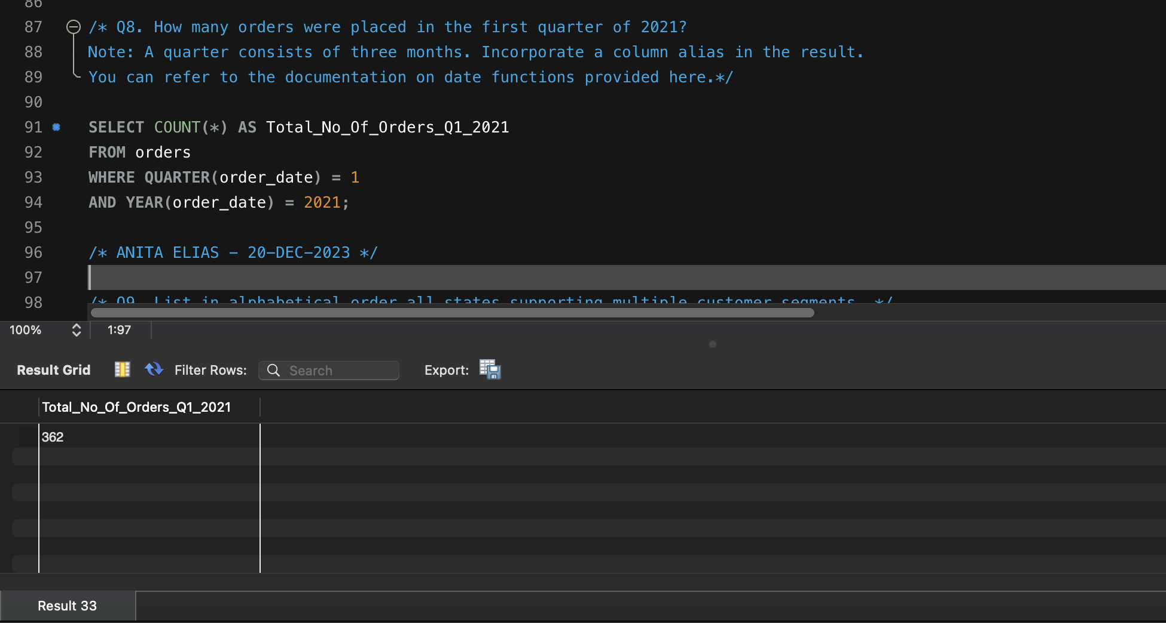

Q 9. List in alphabetical order all states supporting multiple customer segments.

Ans 9.

SELECT c.state AS State_Name, COUNT(DISTINCT c.segment) AS Customer_Segment_By_Number

FROM customer c

GROUP BY State_Name

HAVING COUNT(DISTINCT c.segment) > 1

ORDER BY State_Name;

43 rows were returned in the answer.

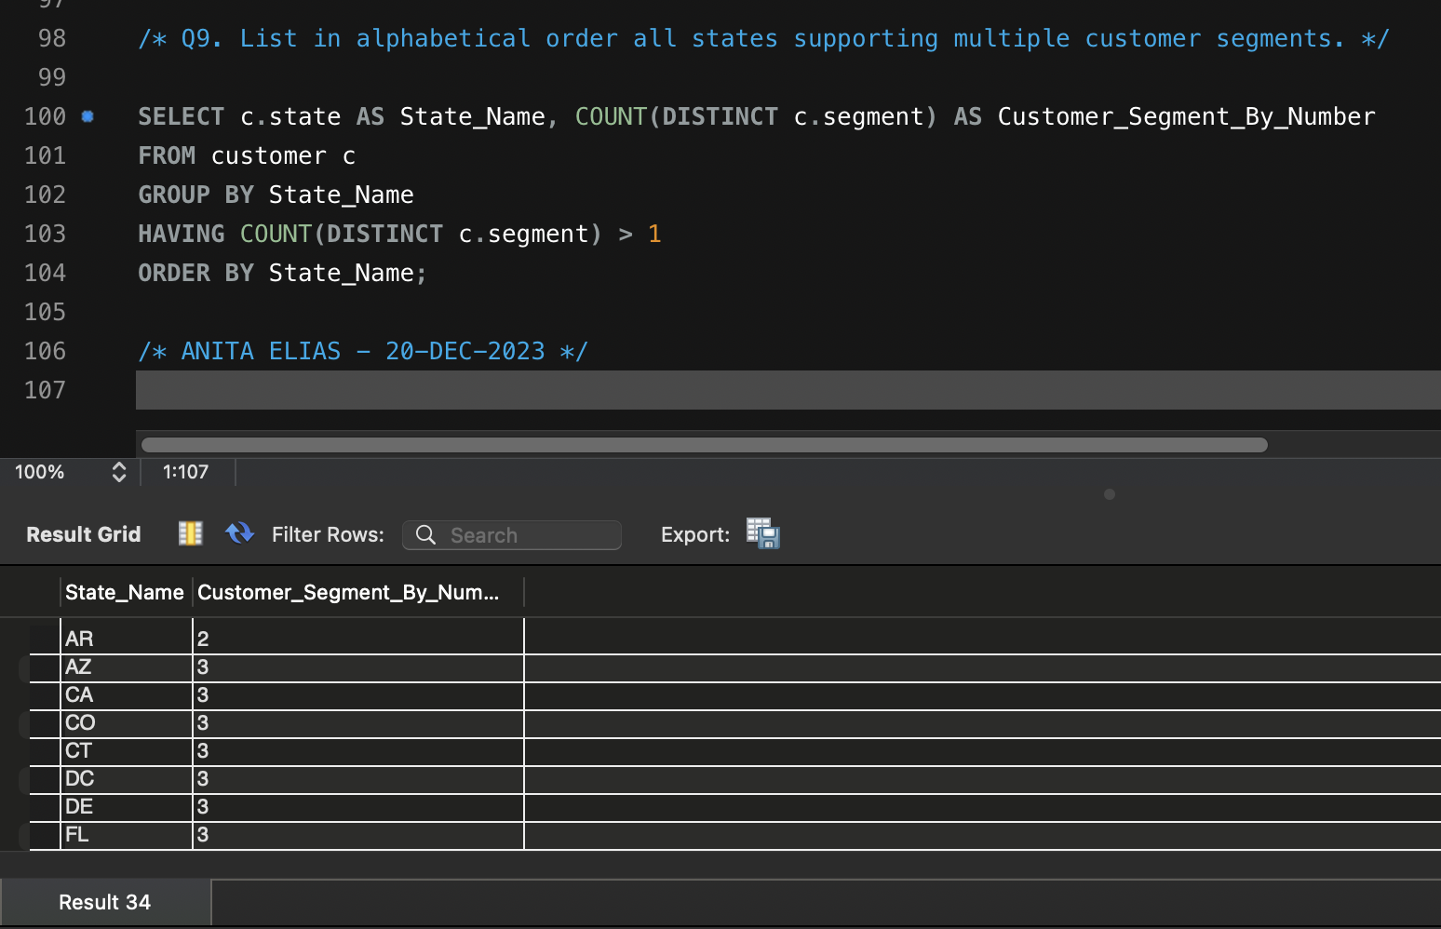

Q 10. To help the commercial sales department with its marketing, find all customers in the corporate segment who have not placed any orders. Include each customers’ first name, last name, street, city, state, and zip code. Sort the results by the last name first and then by the first name.

Ans 10.

SELECT c.first_name AS Customer_First_Name, c.last_name AS Customer_Last_Name, c.street AS Street,

c.city AS City, c.state AS State, c.zipcode AS Zipcode

FROM customer c

WHERE c.segment = 'CORPORATE' AND c.customer_id NOT IN (SELECT customer_id FROM orders)

GROUP BY c.customer_id

ORDER BY Customer_Last_Name, Customer_First_Name;

683 rows were returned in the answer.

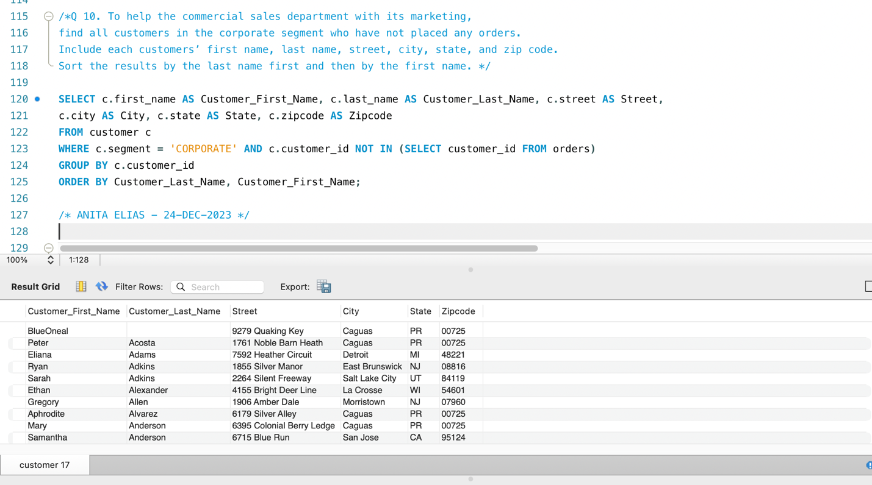

Q 11. There has been a recall of the product Nike Mens Free 5.0+ Running Shoe. TerpBuy would have to offer a discount coupon to all customers who purchased this product. Find all orders that included this product as a part of the purchase. For all such orders, list the customers’ first names, last names, street, state, zip code, and order date. Each customer can be offered only one discount coupon. Hence, do not list the same customer more than once.

Ans 11.

SELECT DISTINCT c.first_name AS Customer_First_Name, c.last_name AS Customer_Last_Name, c.street AS Street,

c.state AS State, c.zipcode AS Zipcode, o.order_date AS Order_Date, p.product_name AS Product_Name

FROM customer c

INNER JOIN orders o ON o.customer_id = c.customer_id

INNER JOIN order_line ol ON ol.order_id = o.order_id

INNER JOIN product p ON p.product_id = ol.product_id

WHERE p.product_name = 'Nike Mens Free 5.0+ Running Shoe'

ORDER BY Customer_First_Name;

244 rows were returned in the answer.

Q 12. Premium customers are those customers who have placed orders with order amounts greater than the average order amount. For each customer, find the first and last names, and the order amount for all orders that exceeded the average order amount.

Ans 12.

SELECT c.first_name AS Customer_First_Name, c.last_name AS Customer_Last_Name, SUM(ol.total_price) AS Total_Order_Amount

FROM customer c

INNER JOIN orders o ON o.customer_id = c.customer_id

INNER JOIN order_line ol ON ol.order_id = o.order_id

WHERE ol.total_price > (SELECT AVG(total_price) FROM order_line)

GROUP BY c.first_name, c.last_name

ORDER BY Total_Order_Amount;

1000 rows were returned in the answer.

